Week 9 Report

This week I worked on view details page where you can we the details about hotel and also we the pictures, locations and facilities. This is done by fetch details from API about hotel.

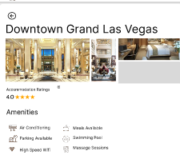

The next thing I did is the hotel rooms details and also calculate the hotel room capacity like I shows the details but also if a rooms capacity is 2 and you add 6 people then it will select 3 rooms for you. And you can put all these selected details in favourites.

